Student Guide to Using Bookstore Credit for Required Books & Supplies
Financial aid is disbursed after the term begins, and financial aid refunds are issued to enrolled and attending students after the class Census Date.
You can purchase your book/supplies (up to $500) from a TCC campus bookstore or online during the bookstore credit timeframe.
With the Trailblazer Laptop Program, you may be eligible to purchase a laptop (up to $750) through the online TCC bookstore. You must have a minimum of $560 available beyond the $500 allotment for books and supplies.
If you do not use any bookstore credit, if eligible, you will receive a Book Advance of up to $500 to use at a bookstore outside of TCC.

Bookstore Credit Timeframes
To find out when you can make TCC bookstore purchases using your bookstore credit balance, visit the Financial Aid Refunds FAQs. Scroll down to Bookstore Credit Balance Questions and click on What is the timeframe for bookstore credit?

Important Financial Aid Terminology to Know
- Financial Aid: The initial offer of financial assistance that helps students pay for college. This can include grants, scholarships, work-study, and student loans.
- Anticipated Financial Aid: The amount of eligibility, based on the initial financial aid offer, enrollment intensity (actual number of hours), and the start date of each class. For classes that start after the first day of the term, this will appear 10 days before the class’s start date.
- Transmit/Disbursement: When your financial aid funds are applied to your term balance on your student account.
- Financial Aid Credit Balance: This occurs when the transmitted financial aid applied to your student account exceeds the term balance.
- Bookstore Credit Balance: The credit balance available to use at the bookstore for bookstore charges, which is based on anticipated financial aid minus your term balance.
  - A maximum of $500 is allotted for books and supplies.
  - A maximum of $750 is allotted for the Trailblazer Laptop Program. Must have a minimum of $560 available beyond the $500 allotment for books and supplies.
- Bookstore Credit Timeframe: The time during which you can use your bookstore credit balance.
- Bookstore Charges: The cost for required books, supplies, and other educationally related goods you purchased using your bookstore credit balance during the bookstore credit timeframe.
- Book Advance: Maximum $500 of Financial Aid credit balance that may be disbursed if you do not use any of your bookstore credit at the campus bookstore during the bookstore credit timeframe.
- Financial Aid Refund: The credit balance issued to a student of any remaining amount after your term balance is fully funded, and attendance is verified.

Determining bookstore credit balance
Complete the following steps to check the bookstore credit balance available to use at the TCC bookstore:
- Log in to MyTCCTrack
- Select the term
- Review the semester's totals and balance.
- The bookstore credit balance is based on anticipated financial aid minus your term balance. If you have anticipated financial aid and the balance is a credit amount (e.g. -$100), you may use up to $500 (if eligible) at the TCC Bookstore, according to the Bookstore Credit Balance.
Note: The amount of credit shown in your Student Account may change due to future account activity. The examples shown in this document may not represent all activities that could occur in your account. Please contact Business Services for more detailed account information.
Example: The $820.58 in Charges is the total of Tuition and Fees, and TCC Plus Digital Material. Under the Financial Aid section, the $924 is the anticipated financial aid. The credit balance of -$103.42 is the Charges minus Anticipated Financial Aid, which can be used at the TCC campus bookstore.

Mobile device view:
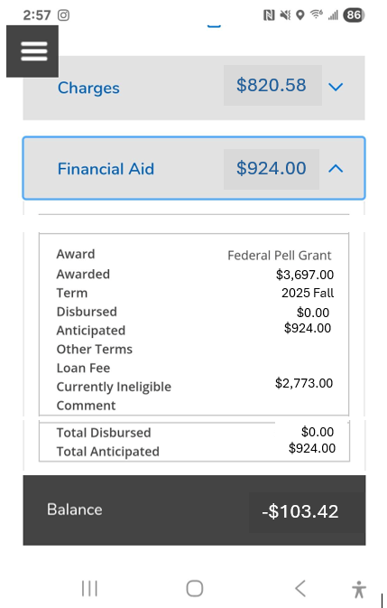
Desktop view:
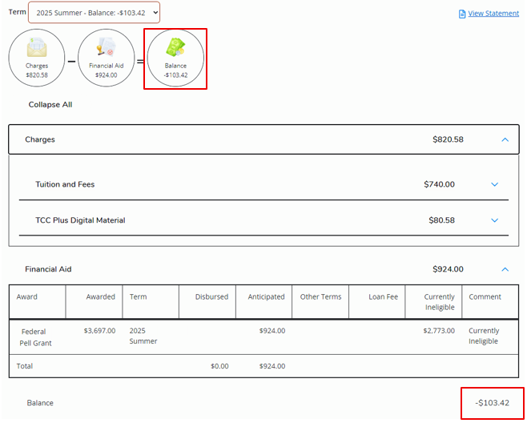

Find Bookstore Charge Totals
Complete the following steps to find your bookstore charge totals.
- Log in to MyTCCTrack
- Select the term
- Expand the Charges section.
Contact the bookstore if you would like an itemized list of your purchases.
Example: The $1,144.16 in Charges is the total of Tuition and Fees, TCC Plus Digital Material and Miscellaneous. The $167.15 under Miscellaneous is Bookstore Charges.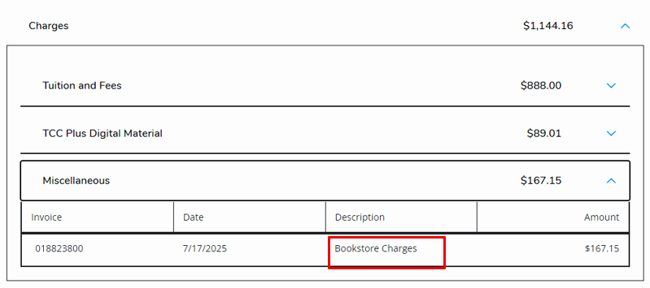
- If your anticipated financial aid is reduced or your term balance is increased, after using the previous bookstore credit balance, you are responsible for the resulting charges on your student account. Unpaid balances will result in registration holds and may be sent to collections if not paid in a timely manner.
  - For example, the initial credit balance was $500, and you charged $300 at the bookstore. Then, your anticipated financial aid was reduced to $200. The anticipated financial aid of $200 minus the bookstore charge of $300 leaves a balance of $100 owed on your student account.
Scenarios | Initial Bookstore Credit Balance | Bookstore Charges | New Bookstore Credit Balance | Amount Owed | Potential FA Refund
#1 | $500 | $300 | $200 | $100 | $0
#2 | $1000 | $300 | $0 | $300 | $0
#3 | $1000 | $300 | $500 | $0 | $200

Purchasing Books/Supplies
You can purchase your book/supplies (up to $500) from a TCC campus bookstore or online.

Purchase books/supplies from a TCC campus bookstore
- Visit the TCC campus bookstore in person or online.
- The bookstore will know your bookstore credit balance during the bookstore credit timeframe. Changes to your bookstore credit balance may take up to 24 business hours to show in your student account.
- Bookstore charges may take up to 48 business hours to show in your student account.
- By using the bookstore credit balance for books, supplies, and other educationally related goods, you are authorizing TCC to apply your financial aid disbursement towards the bookstore charges added to your student account.

Purchase books/supplies online
- Login to tccd.bncollege.com or create an account using your my.tccd email to select items.

Items eligible for purchase using bookstore credit balance:
- Course Materials (excluding TCC Plus): new, used, rentals, digital
- Course Required Uniforms
- School/Course Supplies and backpacks
- Electronics - flash drives, computer mice, headphones, speakers, phone charging options and accessories
- At checkout, on the Payment Information page,
  - Select SFA/3rd Party if you are using your bookstore credit balance for payment.
    - If you are renting a book, you must enter Credit Card information FIRST (for collateral), then select SFA/3rd Party.
  - Check the box next to Internal Provider
  - Enter your Student ID number
  - Select Apply SFA Funds
  - Select another form of payment if you know your aid won’t cover the full purchase price.
  - Select Proceed to checkout
- Review and make any necessary changes, then select Place Order.

Example: The TCC online bookstore Payment Information screen, under Order Summary, shows a purchase of $125.84, plus fees, totaling $138.40. The student selected “SFA / 3RD PARTY” to use their Bookstore Credit as payment and checked the box next to “Internal Provider”.
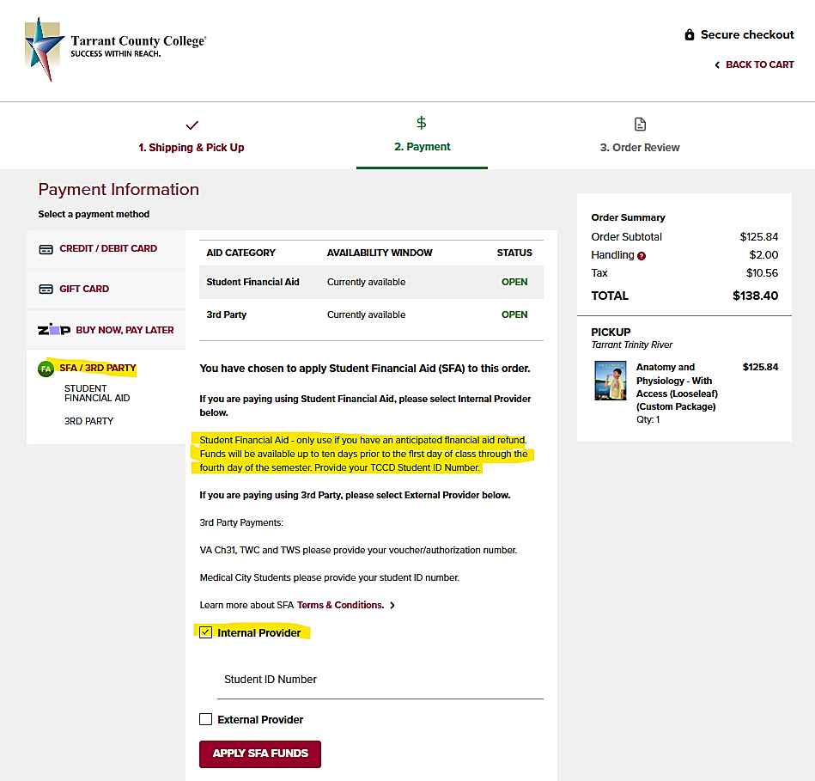

Purchasing a laptop
For the first bookstore timeframe only, if you have $560-$750 in your bookstore credit balance beyond the $500 allotment for books and supplies, you may be eligible to purchase a laptop at a discounted price.
You will receive an email from Barnes & Noble with a promo code to use when purchasing an eligible laptop through the Trailblazer Laptop Program. The email will come from sm8243@bncollege.com. Check your spam or junk folder if you don’t see it in your my.TCC email box.

Applying the promo code
- Login to tccd.bncollege.com or create an account using your my.tccd email to select items.
- Once you have the laptop in your cart, enter the promo code in the provided field on the right side of the screen and click APPLY.
- Click Proceed to Checkout.

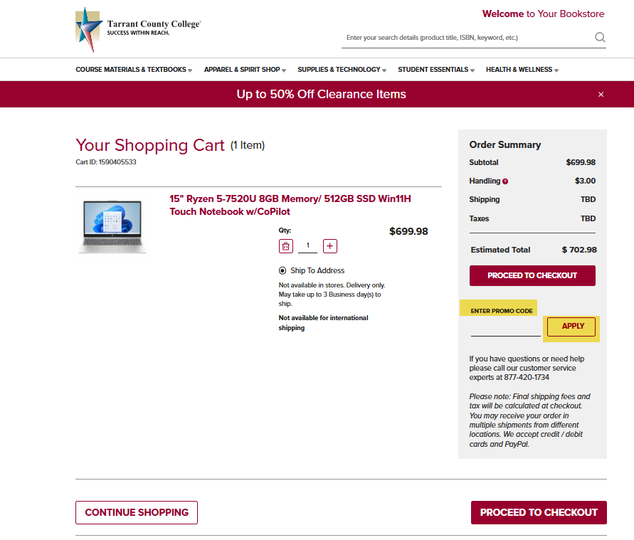
- At checkout, on the Payment Information page,
  - Select SFA/3rd Party if you are using your bookstore credit balance for payment.
    - If you are renting a book, you must enter Credit Card information FIRST (for collateral), then select SFA/3rd Party.
  - Check the box next to Internal Provider
  - Enter your Student ID number
  - Select Apply SFA Funds
  - Select another form of payment if you know your aid won’t cover the full purchase price.
  - Select Proceed to checkout
- Review and make any necessary changes, then select Place Order.

TCC Campus Bookstore Refunds
- If you return a bookstore purchase that was charged against your bookstore credit balance, your student account will be credited in accordance with the bookstore refund policy. It may take 24-48 business hours to show in your student account. If this results in a credit balance on your student account, it will then follow the normal refund schedule.
- Bookstore refunds will be displayed in MyTCCTrack as “Bookstore Charge Adjustment” under the “Miscellaneous” subheading under Charges.
Example: The $272.52 in Charges is the total of Tuition and Fees, TCC Plus Digital Material and Miscellaneous. The $0 Miscellaneous charge is the result of $221.87 in Bookstore Charges minus the Bookstore Charge Adjustment of -$221.87.

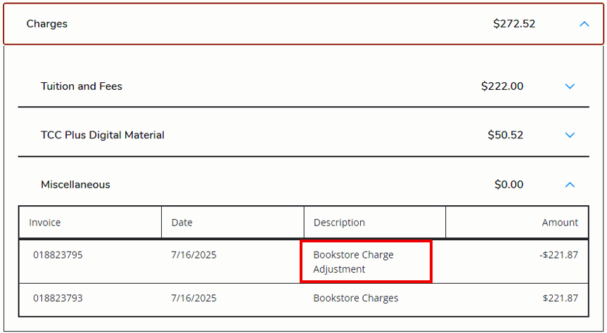

Purchase Required Books/Supplies from Another Source
If you wish to buy books and supplies outside of a TCC campus bookstore, and you do not use any of your bookstore credit at the campus bookstore, you will be issued a Book Advance of up to $500 by the 7th day of the term, if eligible. If you use any of your bookstore credit, you will not receive a book advance.

